



MICROSOFT ARCHITECTURE BEST PRACTICE FOR SECURITY
USECASE: EXTENDING ON-PREMISES ACTIVE DIRECTORY FEDERATION SERVICES (AD FS) TO AZURE)

Document Title | Microsoft Cloud Center of Excellence Overview
Presales/Technical Head | Tushar Mehrotra/Rohit Pandey
CCoE Lead | Ravishankar N
Creation Date | September 2025
Version | Description | Modified by | Date | Approved by | Date
1 | Initial Architecture design | AJEET KUMAR | 09/09/2025 | Ravi Shankar | 09/09/2025
2 | Reusability & scalability | AJEET KUMAR | 12/11/2025 | Ravi Shankar | 12/11/2025
Contents
1
1. Executive Summary 3
2. Scope and Applicability 3
3. Business Scenario Overview 3
4. Reference Architecture Overview 4
4.1 Architecture Description 4
5. Logical Architecture Components 4
5.1 Hybrid Network and Connectivity 4
5.2 Active Directory Domain Services (AD DS) Layer 4
5.3 AD FS Federation Services Layer 5
5.4 Web Application Proxy (WAP) Layer 5
5.5 Load Balancing and Availability 5
5.6 Security, Monitoring, and Governance 5
6. Cloud Center of Excellence (CCoE) Enablement Model 5
8. Reusability and Scalability 5
9. Conclusion 6

1. Executive Summary
The solution enables secure, federated authentication and authorization for applications hosted in Azure by integrating them with existing on-premises identity infrastructure.
The architecture supports hybrid identity scenarios where organizations require tight control over authentication while benefiting from Azure scalability and availability.

2. Scope and Applicability
This reference architecture applies to:
- Hybrid identity and access management scenarios
- Organizations using AD FS for federated authentication
- Azure-hosted or hybrid applications requiring federation
- Environments connected via VPN or ExpressRoute
- Enterprise and CCoE-governed Azure platforms
The architecture is designed for secure hybrid authentication use cases.

3. Business Scenario Overview
Many organizations rely on on-premises Active Directory and AD FS to authenticate users and manage access to applications. When applications are extended to Azure, routing authentication traffic back to on-premises infrastructure can increase latency and create availability dependencies.
This architecture addresses these challenges by replicating AD FS, AD DS, and proxy components in Azure, enabling local authentication flows while preserving existing identity trust relationships.

4. Reference Architecture Overview
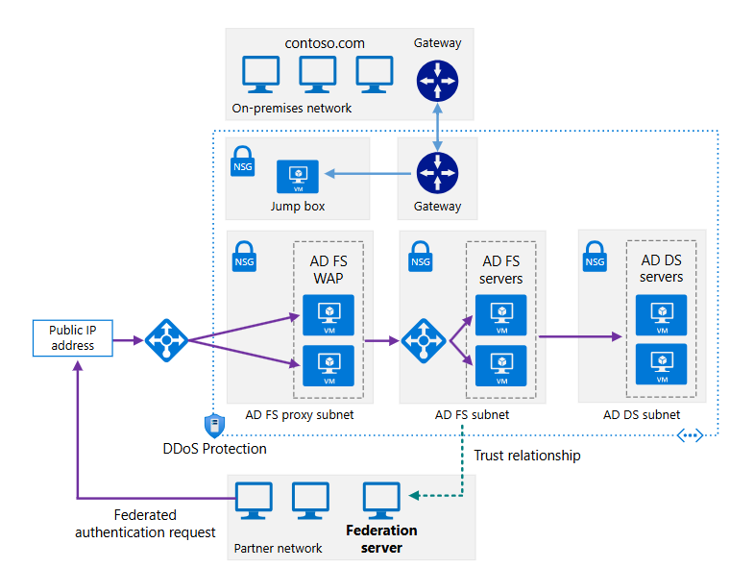

4.1 Architecture Description
The architecture implements a secure hybrid network that extends on-premises identity services to Azure. Core identity components are deployed in dedicated Azure subnets and protected by network security groups (NSGs). External requests are routed through Web Application Proxies to AD FS servers, which authenticate users before granting access to Azure-hosted applications (relying parties).

5. Logical Architecture Components

5.1 Hybrid Network and Connectivity
- Site-to-Site VPN or Azure ExpressRoute connectivity
- Segmented Azure virtual networks
- Network Security Groups (NSGs) for subnet isolation
Secure connectivity ensures reliable communication between on-premises and Azure identity services.

5.2 Active Directory Domain Services (AD DS) Layer
- AD DS domain controllers deployed as Azure virtual machines
- Dedicated subnet with firewall rules
- Directory replication with on-premises AD
This layer provides core authentication and directory services within Azure.

5.3 AD FS Federation Services Layer
- AD FS servers hosted on Azure virtual machines
- Federation trust relationships with partner organizations
- Claims-based authentication and authorization
AD FS servers validate security tokens and issue claims to Azure-hosted applications.

5.4 Web Application Proxy (WAP) Layer
- Web Application Proxy servers deployed in a perimeter subnet
- Reverse proxy for external authentication traffic
- Protection of internal identity services
WAP servers act as the secure ingress point for federated authentication requests.

5.5 Load Balancing and Availability
- Azure Load Balancer for AD FS and WAP tiers
- Multiple instances for high availability
- Fault-tolerant design across availability zones
Load balancing ensures resilient identity services delivery.

5.6 Security, Monitoring, and Governance
- Role-based access control (RBAC)
- Centralized logging and ing
- Secure administrative access via jump boxes
Governance controls maintain security posture and compliance across identity components.

6. Cloud Center of Excellence (CCoE) Enablement Model
The CCoE uses this architecture to:
- Define enterprise hybrid identity standards
- Govern federation and trust configurations
- Ensure secure access to cloud-hosted applications

8. Reusability and Scalability
- Reusable across multiple hybrid applications
- Scales independently in Azure to meet demand
- Supports additional relying parties and partner federations

9. Conclusion
The Extend On-Premises AD FS to Azure Reference Architecture provides a Microsoft-aligned approach for delivering secure, federated authentication in hybrid environments. By extending AD FS into Azure, organizations gain improved performance, resilience, and scalability while preserving existing identity investments.

